Sri Lanka Institute of Information

Technology



Lab Submission

Lab sheet 07

**IT23782204**

**Pathiraja M.M.S**

**Probability and Statistics|IT2120**

B.Sc. (Hons) in Information Technology

01. 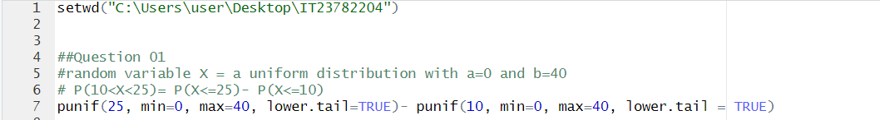



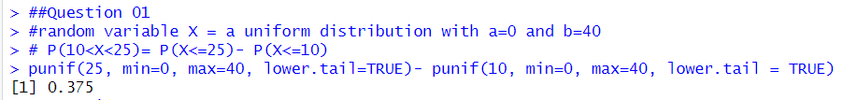

02.





03.

